Financial Model
A complete guide to using the system
Every screen shown here is the Tharwah Industrial Group model — a holding company,
three subsidiaries, six divisions, ten business lines and eleven products.
22 September 2026

What this system does
You type in what your business has done and what you expect it to do. The system turns that into a full set of accounts — profit and loss, cash flow, balance sheet — for every year of your plan, for the group and for each part of it, and keeps them tied together.
You never type a total. You type the facts; every total, every statement and every ratio is worked out.
The three things to know before you start
- You fill in 14 steps, in order — each one builds on the one before. The system tells you what is still blank at the end.
- Everything is entered per business line — the group figure is the lines added up — it is never typed.
- Every plan has three cases — best, base and worst. You fill all three; the outputs let you switch between them.
Who does what
Role | What they can do
Administrator | Everything: fill in, read, and close a plan so nobody can change it.
Model manager | Fill in and read everything. Cannot close a plan or manage people.
Analyst (read-only) | Can open and read every screen. Cannot change anything.
Board / outputs only | Sees the finished statements. The input screens are not available.
Super administrator | Manages companies, people and access. Never sees a plan.

On top of the role, two more things narrow what a person sees:
- Their seat in the org chart — the head of one business line fills in that line and reads that line. The chief executive of a subsidiary gets the whole company. Nobody has to hide anything by hand.
- Their authorities — an administrator can name the exact screens a person opens, and whether each one is to read or to change. This can only take away, never add.
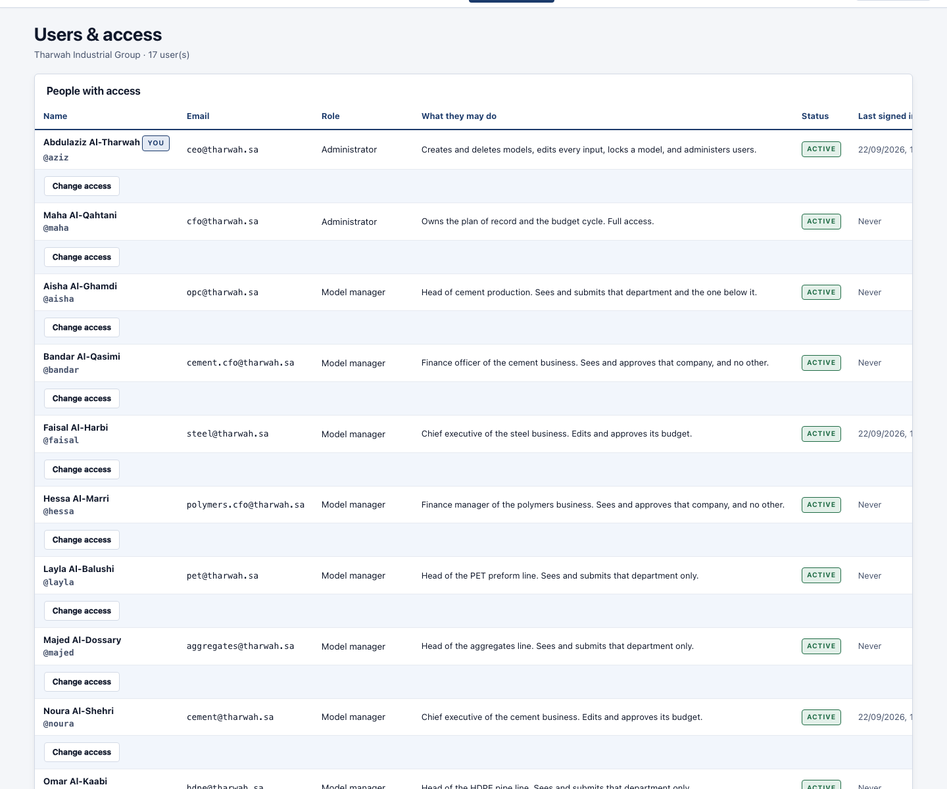
Users and access — each person has a role; their seat and authorities narrow it further.

Step 0 — Setting up the plan
Before any numbers, you tell the system the shape of your business and the shape of the plan. This is on Model settings. You can come back and change it later.
Choice | What it means | Options
Model currency | The currency the plan is reported in. | Any currency
The model runs | How long a column is. | Annual · Quarterly · Monthly
Fiscal year starts in | Your year end. | Any month
Closed years are stated | How you will type your history. | Annual · Quarterly · Monthly
Deepest level | How far down you want a profit and loss. | Group only · Subsidiary · Division / SBU · Business line
Middle levels | Which layers exist in between. | Subsidiaries · Divisions · Products & SKUs · Detailed statements
First forecast year | The first year you are planning. | Any year
Historical years | How many closed years you will type. | Usually 2 or 3
Forecast years | How many years the plan runs. | Usually 5 or 10

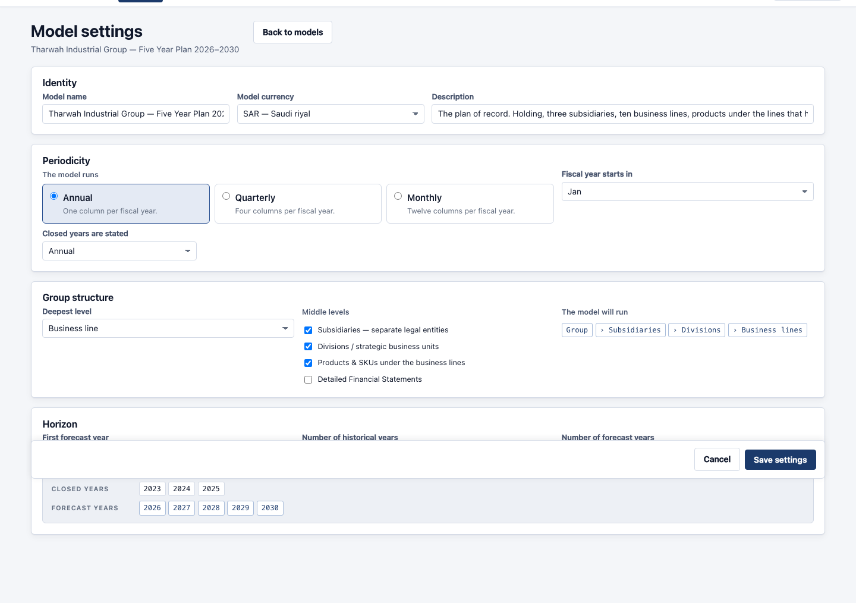
Model settings — the shape of the business and the shape of the plan.
The 14 steps, in order
The bar at the top of every input screen shows all 14. You can jump between them, but filling them in order is easiest because each one uses the one before. Every screen saves with “Save” or “Save & continue”.
Step 1 — Structure
Name the group and list what it is made of: subsidiaries, divisions, and the business lines that actually trade. Everything after this is collected line by line.
You must fill in
- The group name
- Every business line, with the division or company it belongs to
What you can choose
- For each subsidiary — its currency, how much of it you own, the smallest cash balance it must keep, how much of its profit it pays out as dividend, and the share of profit it must hold back by law
- If it is in another currency — the exchange rate at the start — the system translates the rest
Worth knowing: Tharwah: one holding company, three subsidiaries (one of them in dirhams and 60% owned), six divisions and ten business lines.
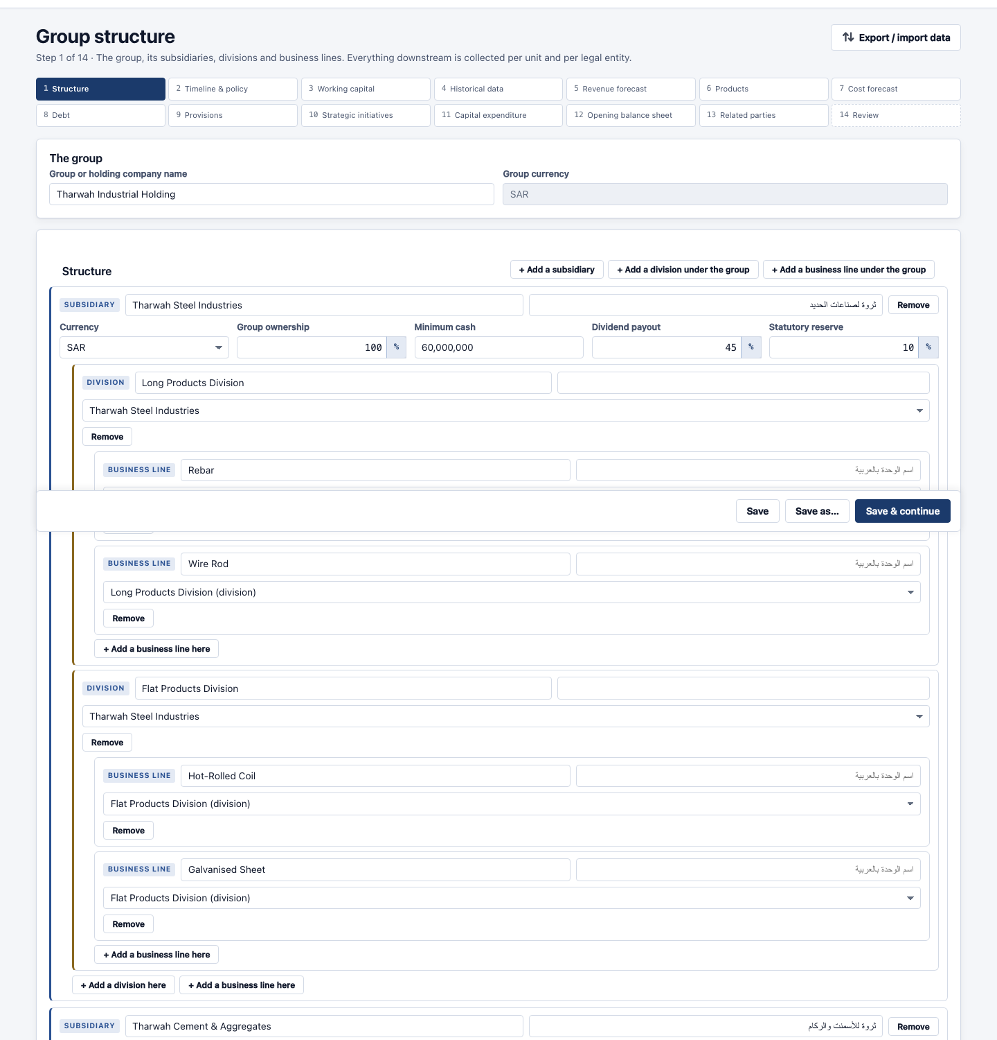
Step 1 — Structure, on the Tharwah plan.

Step 2 — Timeline & policy
The rules the whole plan runs on — one screen, set once.
You must fill in
- Tax or zakat rate and how it is worked out
- How long assets last, for depreciation
- The smallest cash balance the business keeps
What you can choose
- Financing policy — the rate on the overdraft, the rate earned on spare cash, and how much of the profit is paid out as dividend
- Depreciation — separate lives for assets you already own and for new spending, and how much depreciation a new asset takes in its first year
- Reporting currencies — the other currencies a reader may switch the outputs into
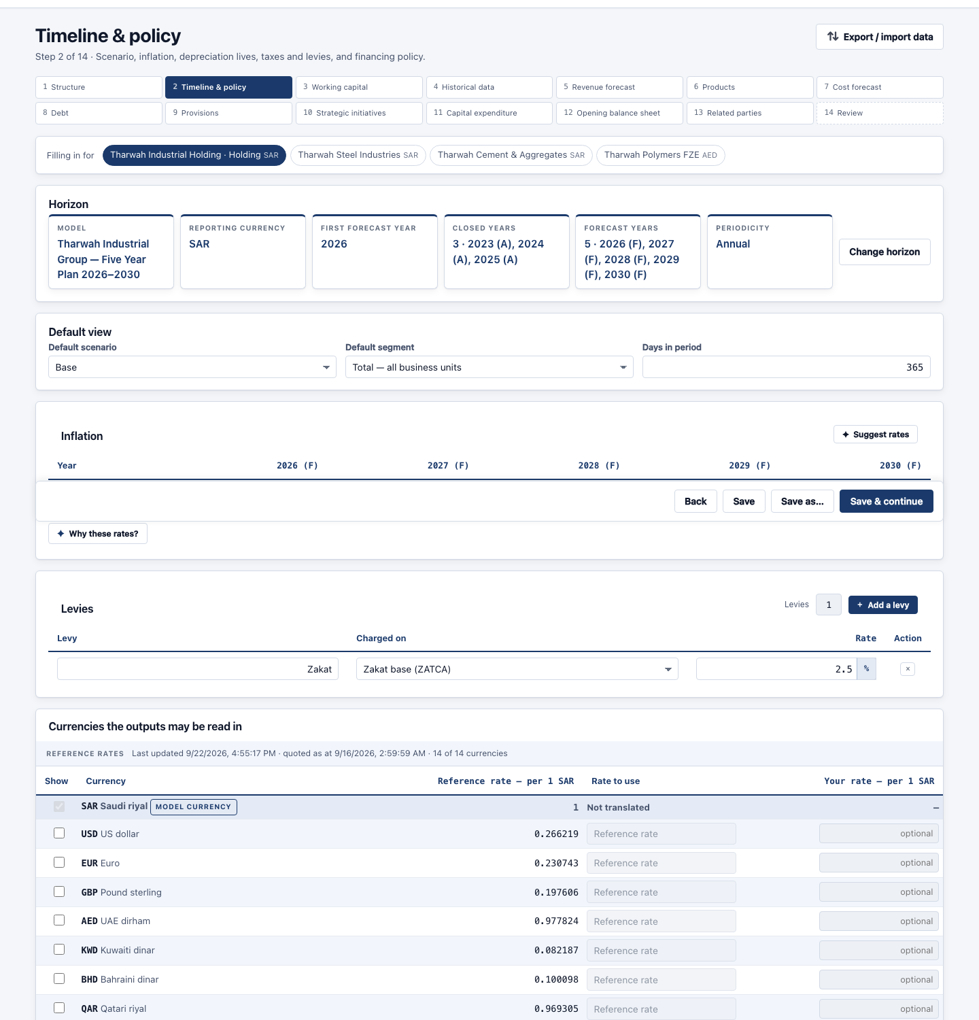
Step 2 — Timeline & policy, on the Tharwah plan.

Step 3 — Working capital
How long money takes to come in and go out. These days drive the receivables, inventory and payables on the balance sheet, and therefore the cash.
You must fill in
- Collection days — how long customers take to pay you
- Inventory days — how long stock sits
- Payment days — how long you take to pay suppliers
What you can choose
- Per line or per company — you chose this at setup; the screen follows it
- Other balances — days for accruals, other receivables and other payables, if you use them
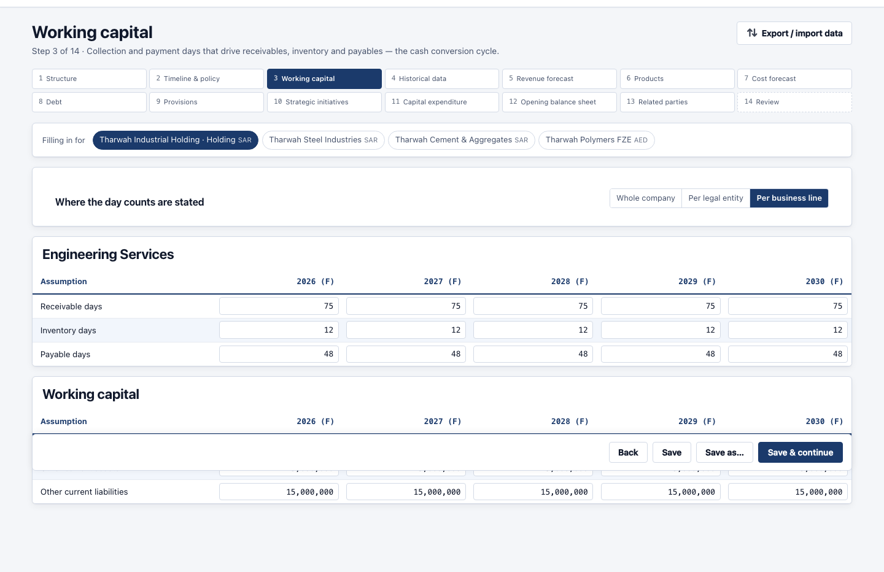
Step 3 — Working capital, on the Tharwah plan.

Step 4 — Historical data
What each business line actually did in the closed years. This is the base the forecast grows from, and the comparison column on every output.
You must fill in
- Revenue for each closed year, per line
- Cost of sales, per line
What you can choose
- Also worth entering — selling costs, admin costs, depreciation and capital spending — so the closed years show a full profit and loss beside the forecast
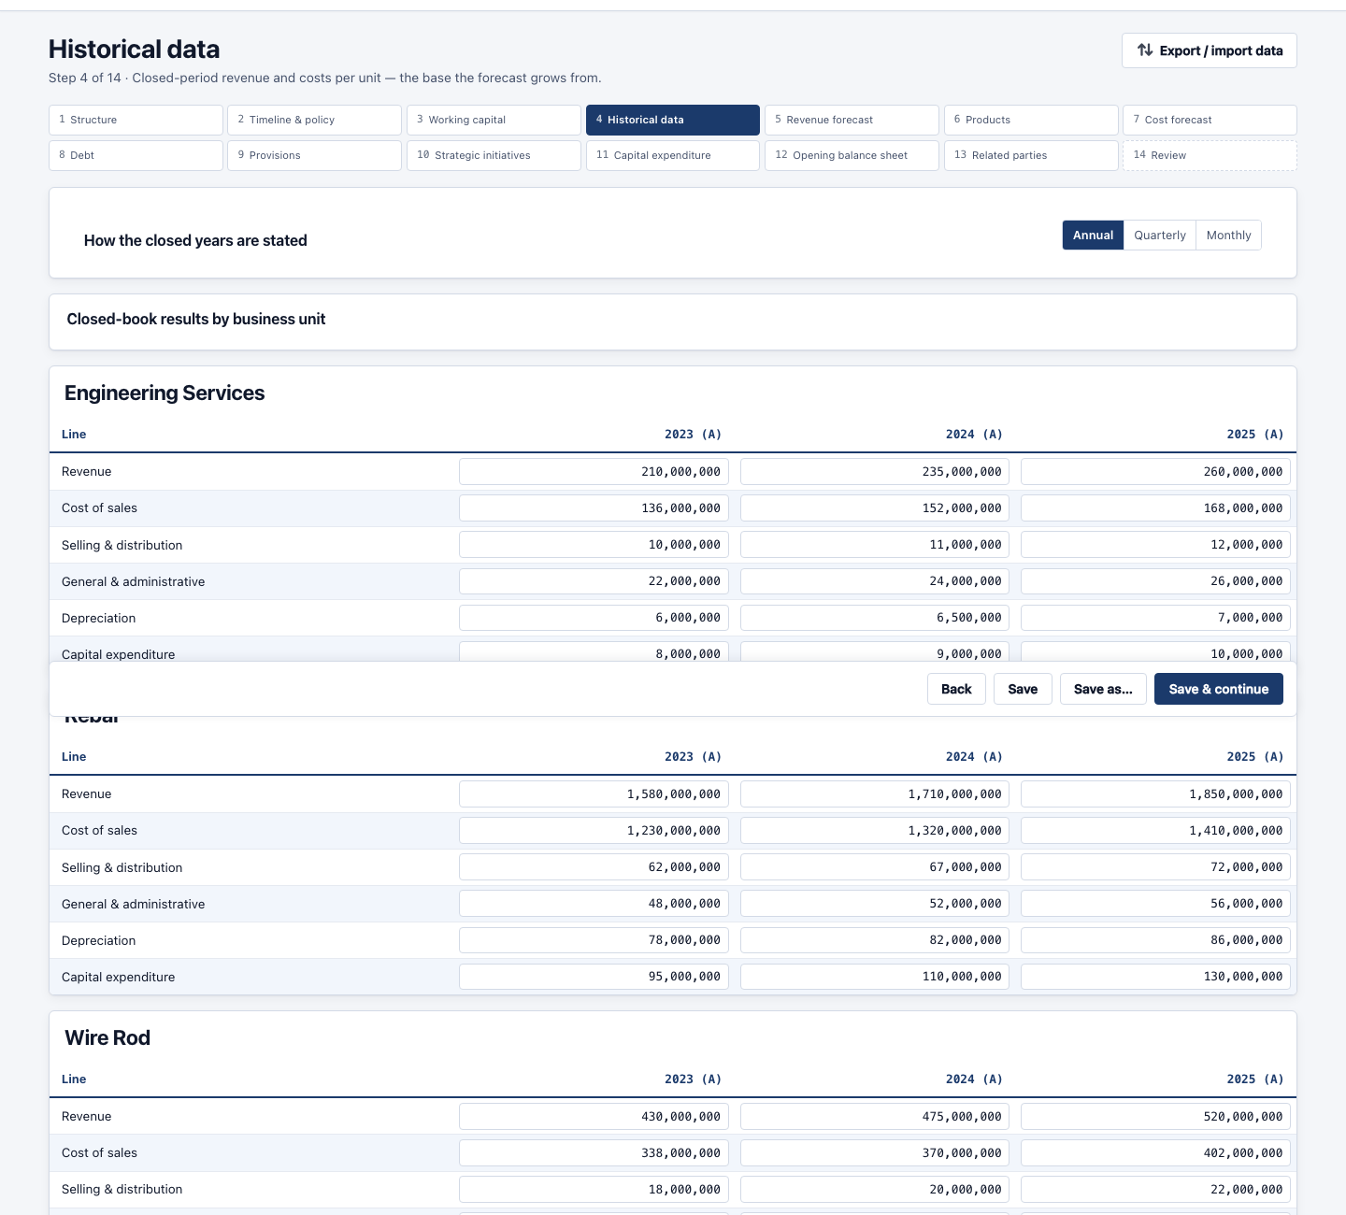
Step 4 — Historical data, on the Tharwah plan.

Step 5 — Revenue forecast
How fast each line grows, for each of the three cases.
You must fill in
- A growth rate for every line, every year, in all three cases
What you can choose
- Growth % or Amount — per line — either say it grows 8% a year, or type the revenue figure yourself
- Three cases — best, base and worst are filled on the same screen, one under the other
Worth knowing: Strategic initiatives are added on top separately, at step 10 — so this number is pure like-for-like growth.
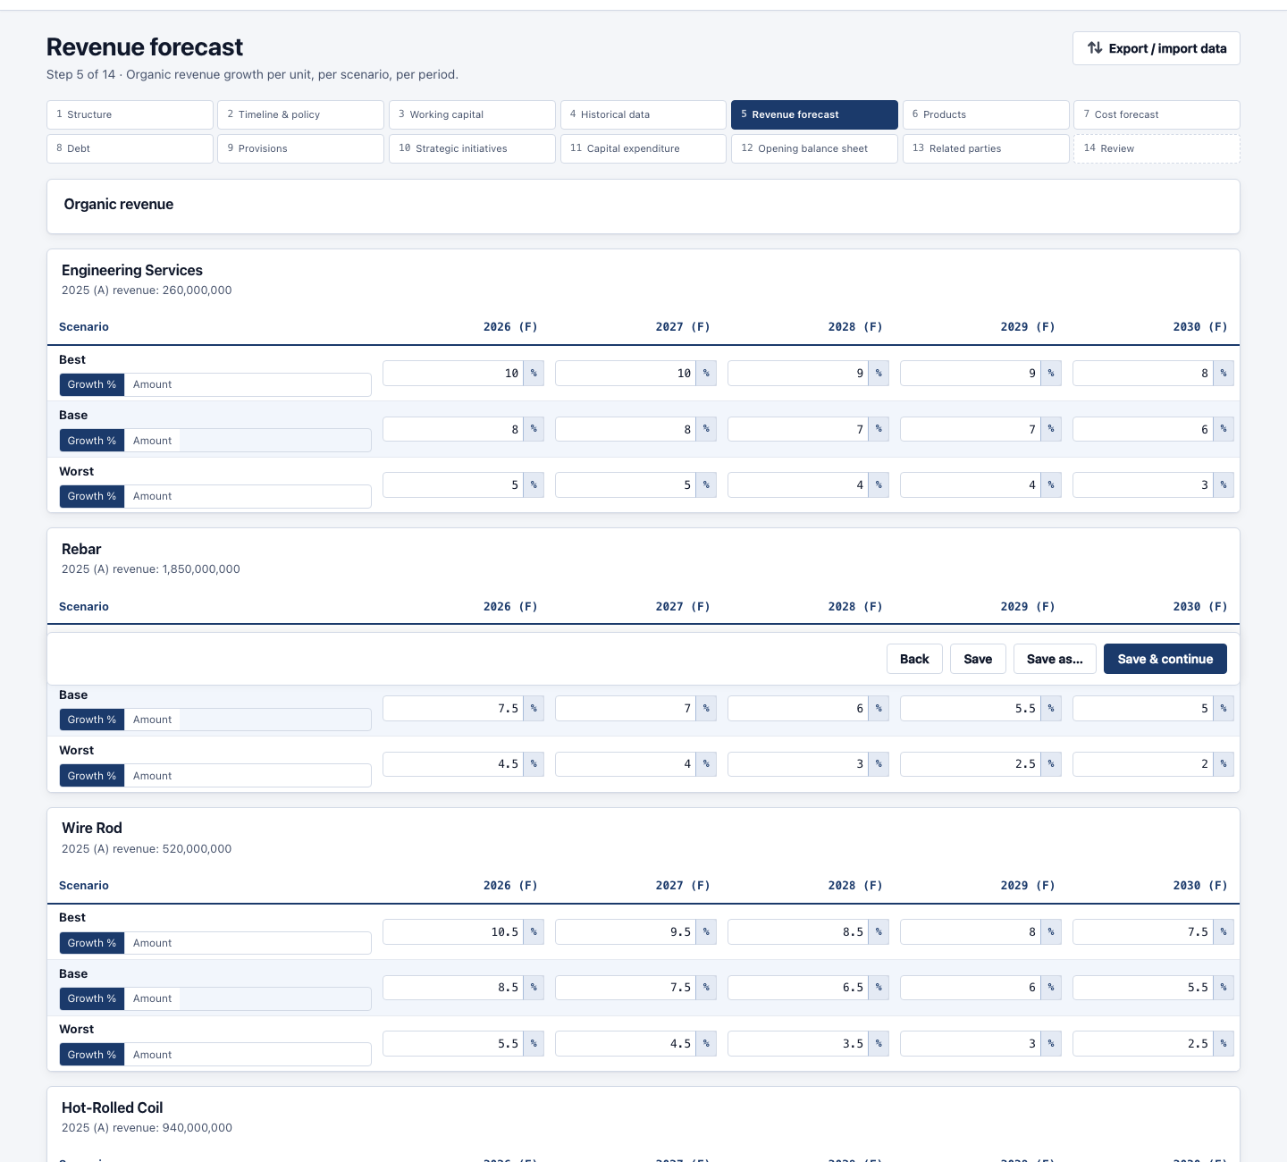
Step 5 — Revenue forecast, on the Tharwah plan.

Step 6 — Products & SKUs
Optional. The individual products a line sells, so you can see what each one really earns.
You must fill in
- Only if you turned products on at setup
What you can choose
- Volume and price, or a revenue amount — per product
- Direct costs — materials, labour and other — the costs that follow each unit
- Direct fixed costs — the costs the product carries whether it sells or not
- Indirect costs — its share of the line’s running costs
- How it carries the overheads above it — for its line, its division, its company and the group — either automatically by its share of revenue, units or direct cost, or a percentage you state yourself
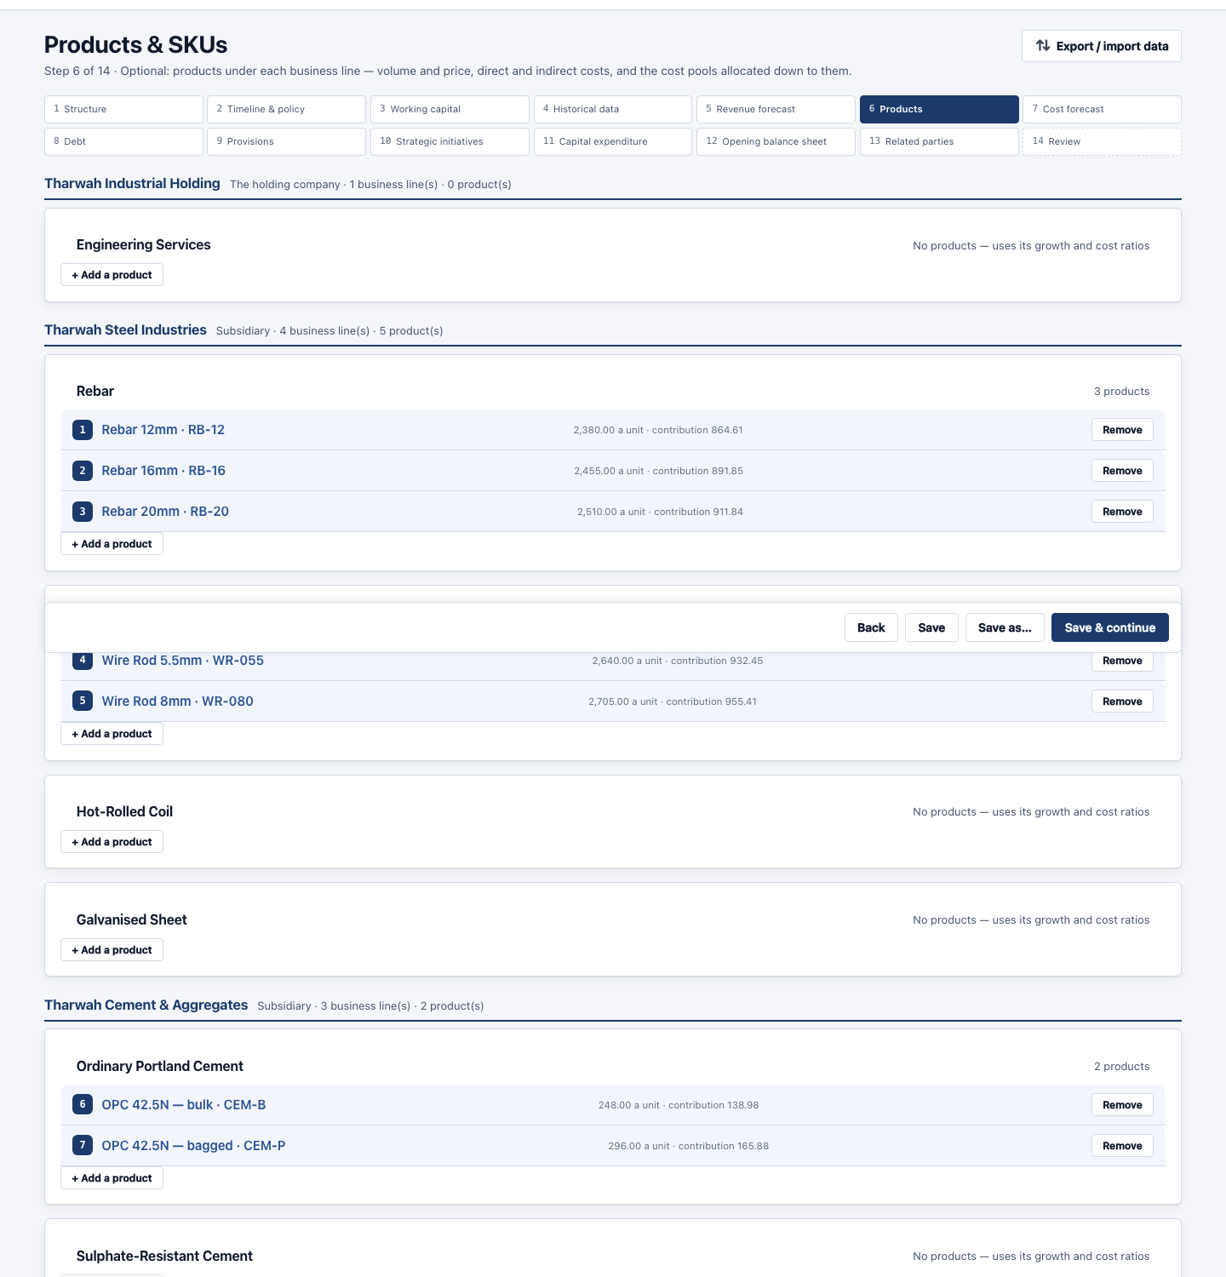
Step 6 — Products & SKUs, on the Tharwah plan.

Step 7 — Cost forecast
What it costs to make the revenue you just forecast.
You must fill in
- A variable cost percentage of revenue, per line, per case
- A fixed cost amount that does not fall when revenue does
What you can choose
- Split variable and fixed — this split is what makes a downside case bite — without it, margins never compress
- Selling and admin costs — same shape: a percentage plus a fixed amount
- Fixed costs rise with inflation — at the rate set in step 2
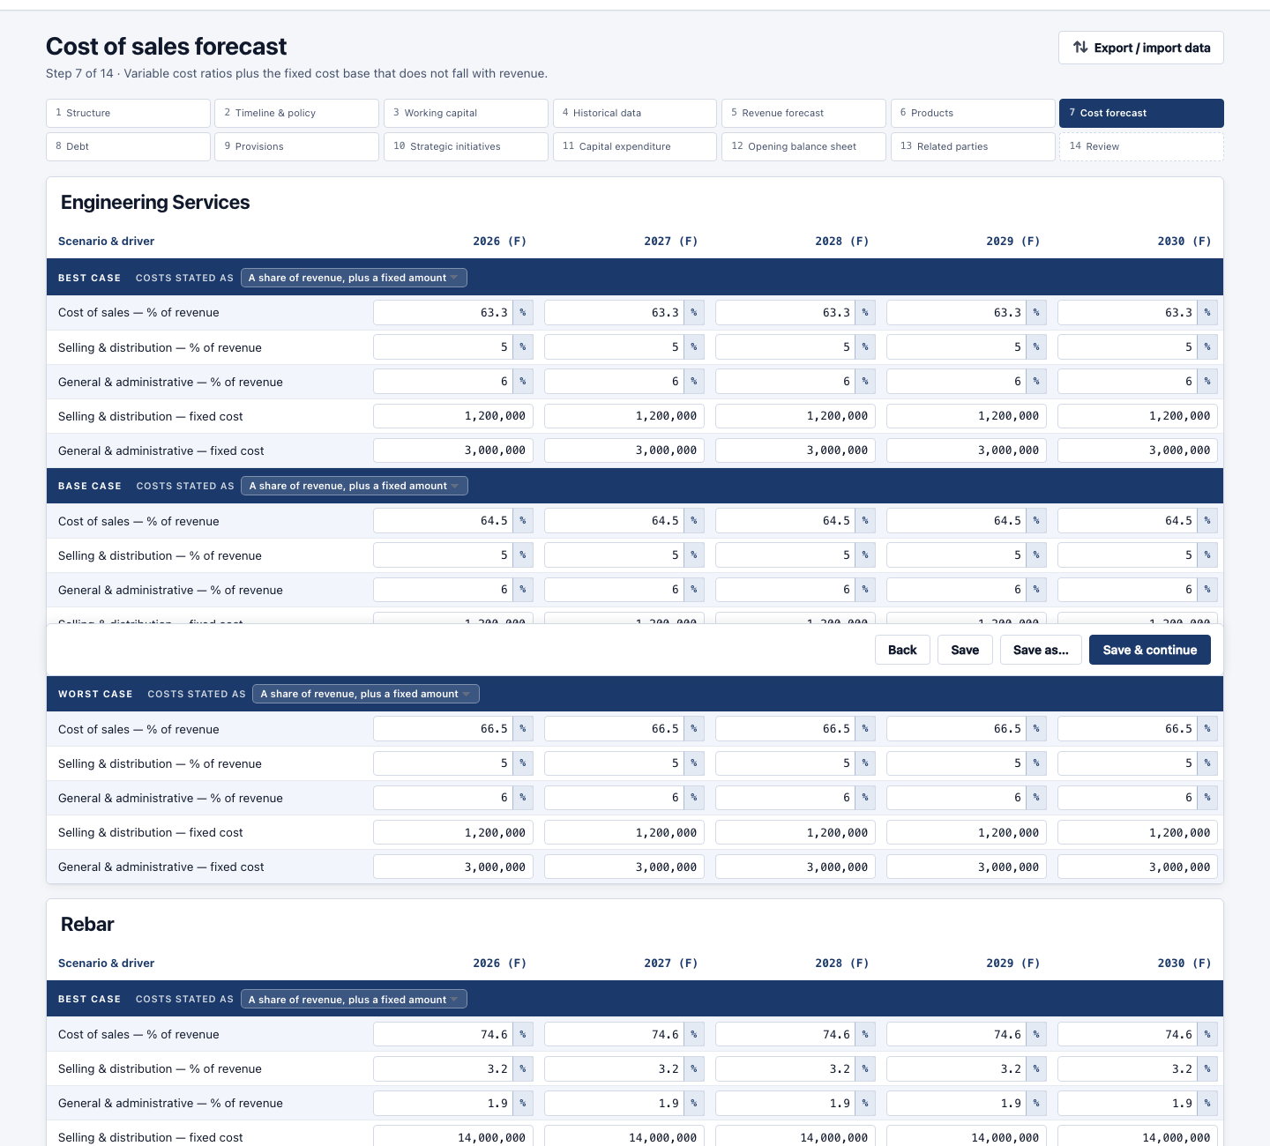
Step 7 — Cost forecast, on the Tharwah plan.

Step 8 — Debt & facilities
Every loan and facility the business has or expects to take.
You must fill in
- For each facility: the amount, when it is drawn, the interest rate and how it is repaid
What you can choose
- Repayment profile — equal instalments, a single payment at the end, or a schedule you type
- Grace period — years before repayment starts
- Security — what is pledged against each facility
- Overdraft — the system draws on it automatically when cash would fall below your minimum
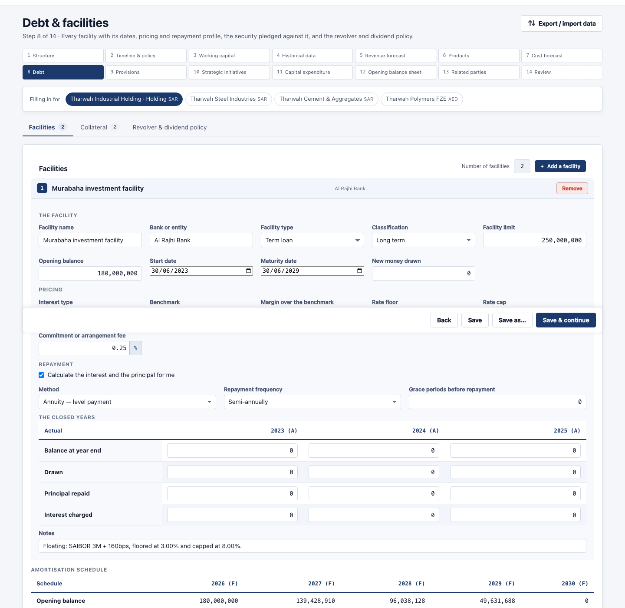
Step 8 — Debt & facilities, on the Tharwah plan.

Step 9 — Provisions
What the business sets aside — end of service, warranties, legal claims, doubtful debts.
You must fill in
- For each provision: what it is called and how much is charged each year
What you can choose
- How it is charged — as a percentage of revenue, a fixed amount, or figures you type
- Where it sits — which line of the balance sheet it appears on
- What is paid out — the amounts settled or released each year
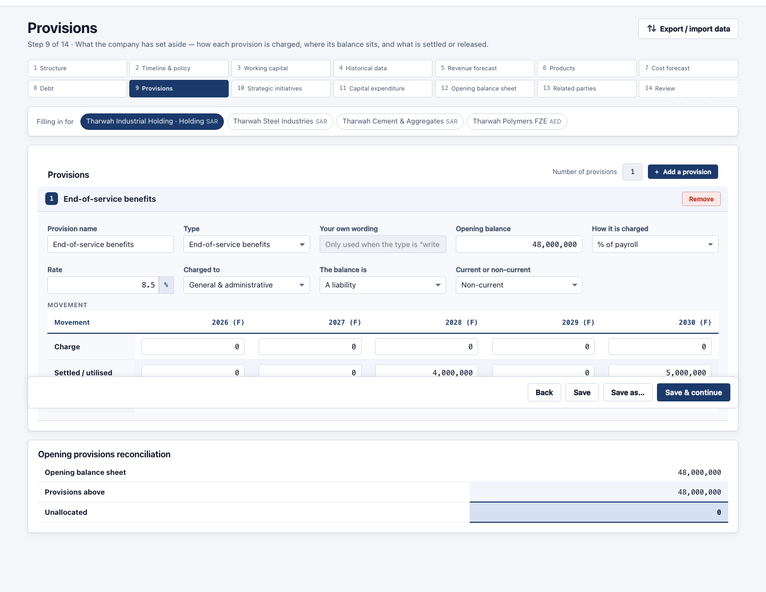
Step 9 — Provisions, on the Tharwah plan.

Step 10 — Strategic initiatives
New projects, each with its own small profit and loss, added on top of the organic plan.
You must fill in
- For each initiative: its name, the line it belongs to, when it starts
What you can choose
- Its own revenue and costs — year by year
- A cost saving instead — an initiative can reduce costs rather than add revenue
- The capital it needs — linked to the spending you enter at step 11
- Which cases it appears in — so an ambitious project can sit in the best case only
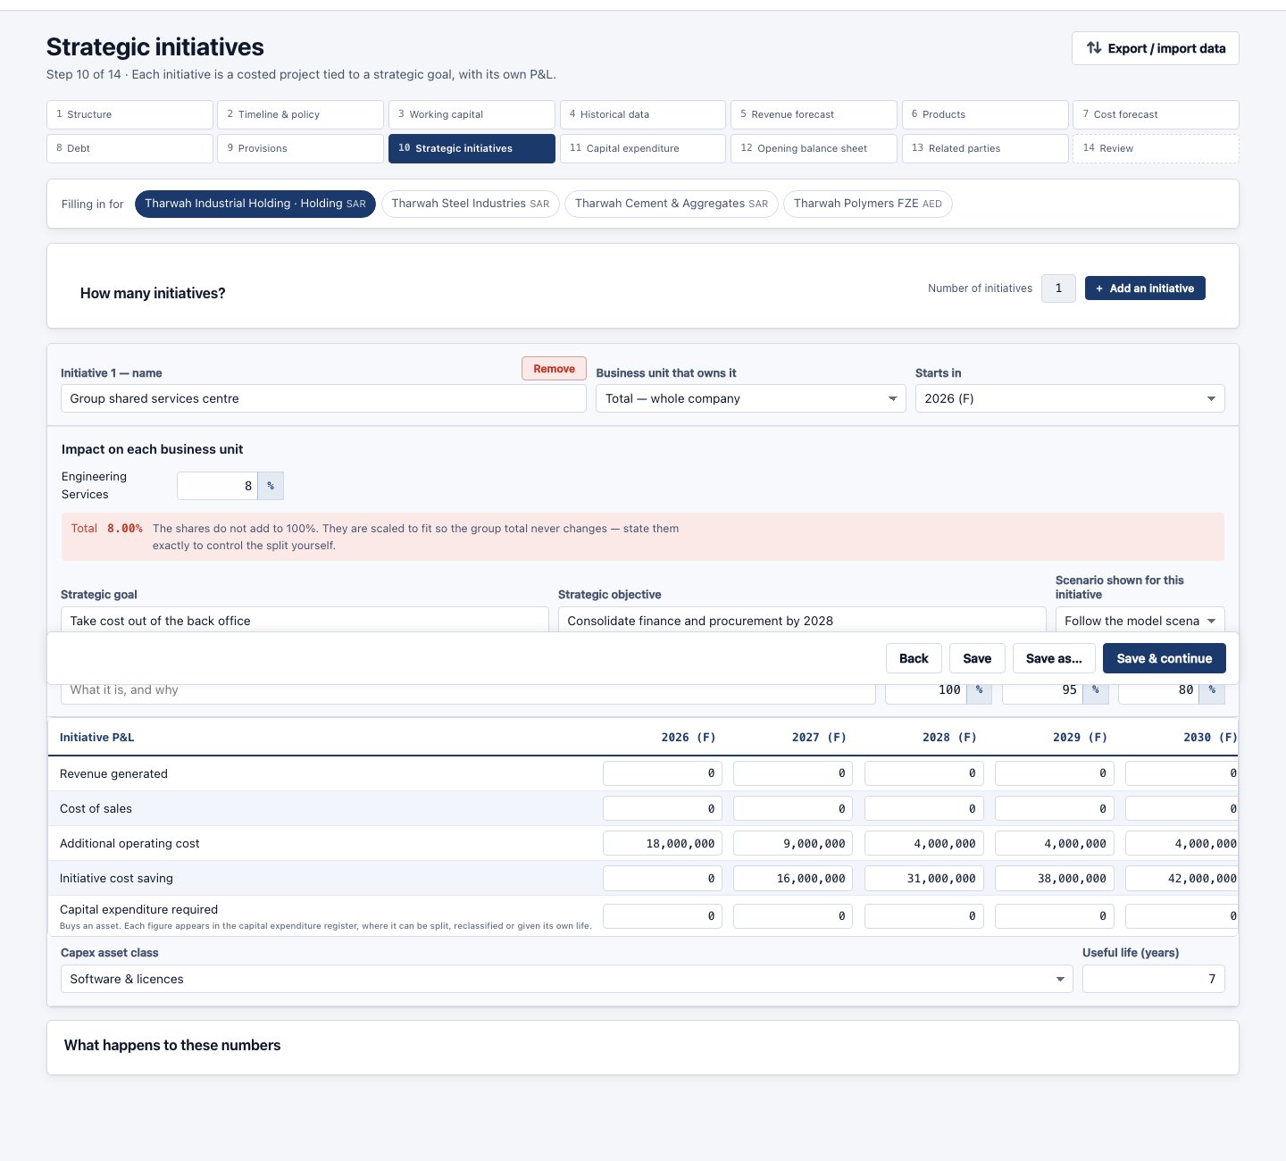
Step 10 — Strategic initiatives, on the Tharwah plan.

Step 11 — Capital expenditure
What the business buys — plant, buildings, vehicles, equipment.
You must fill in
- For each asset: what it is, what it costs, and the year it is bought
What you can choose
- Asset class — which sets how fast it depreciates
- The line it belongs to — so its depreciation lands in the right place
- Tie it to an initiative — or leave it standing on its own
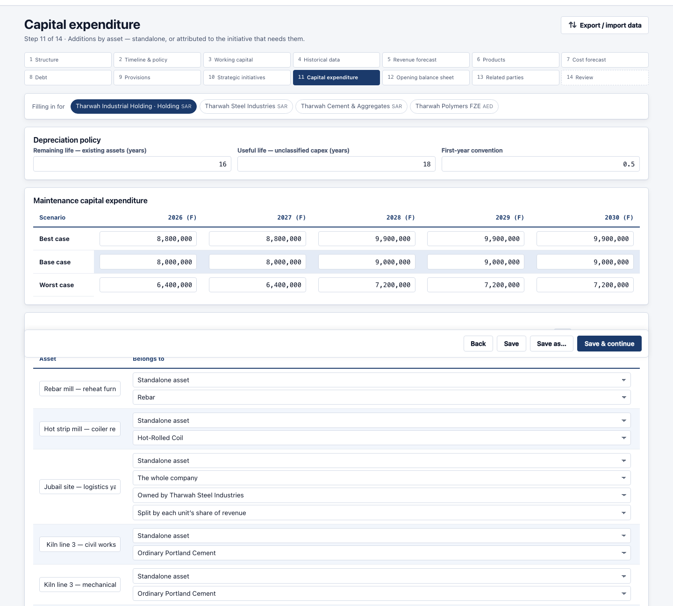
Step 11 — Capital expenditure, on the Tharwah plan.

Step 12 — Opening balance sheet
A balance sheet for each closed year. The last one is where the forecast starts from.
You must fill in
- Every balance: cash, receivables, inventory, fixed assets, payables, debt, capital, reserves
- It must balance — the screen tells you if it does not
What you can choose
- Per company — on a group, each subsidiary gets its own opening balance sheet
Worth knowing: This is the one step the forecast cannot start without. Assets must equal liabilities plus equity, and the screen shows the difference until they do.
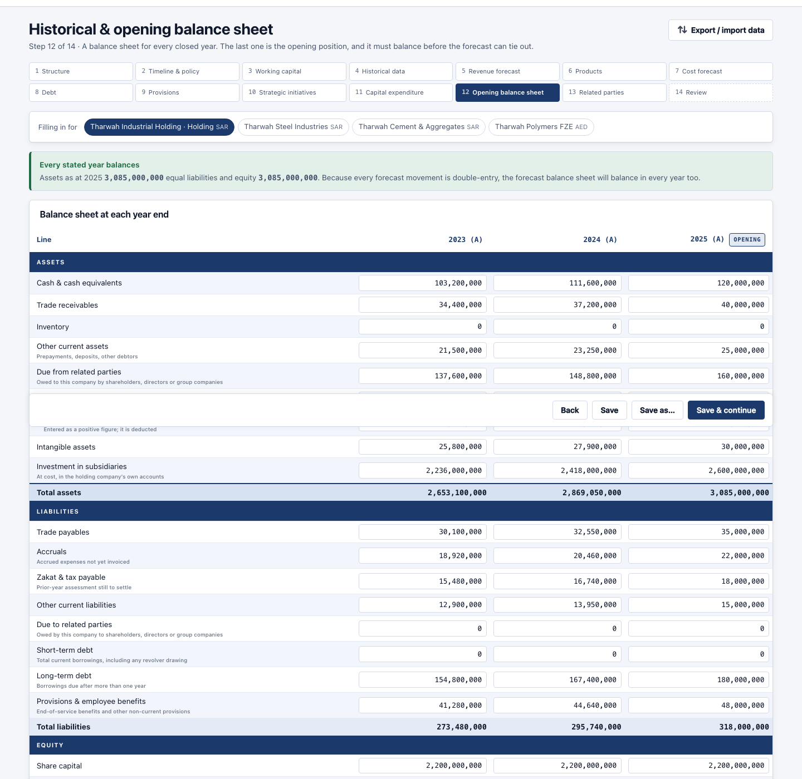
Step 12 — Opening balance sheet, on the Tharwah plan.

Step 13 — Related parties
Money owed to and from companies connected to you, and sales between members of your own group.
You must fill in
- Only if you have them
What you can choose
- Balances — due from and due to each related party
- Sales inside the group — seller, buyer and amount — removed when the group is added up, so the group does not count a sale to itself
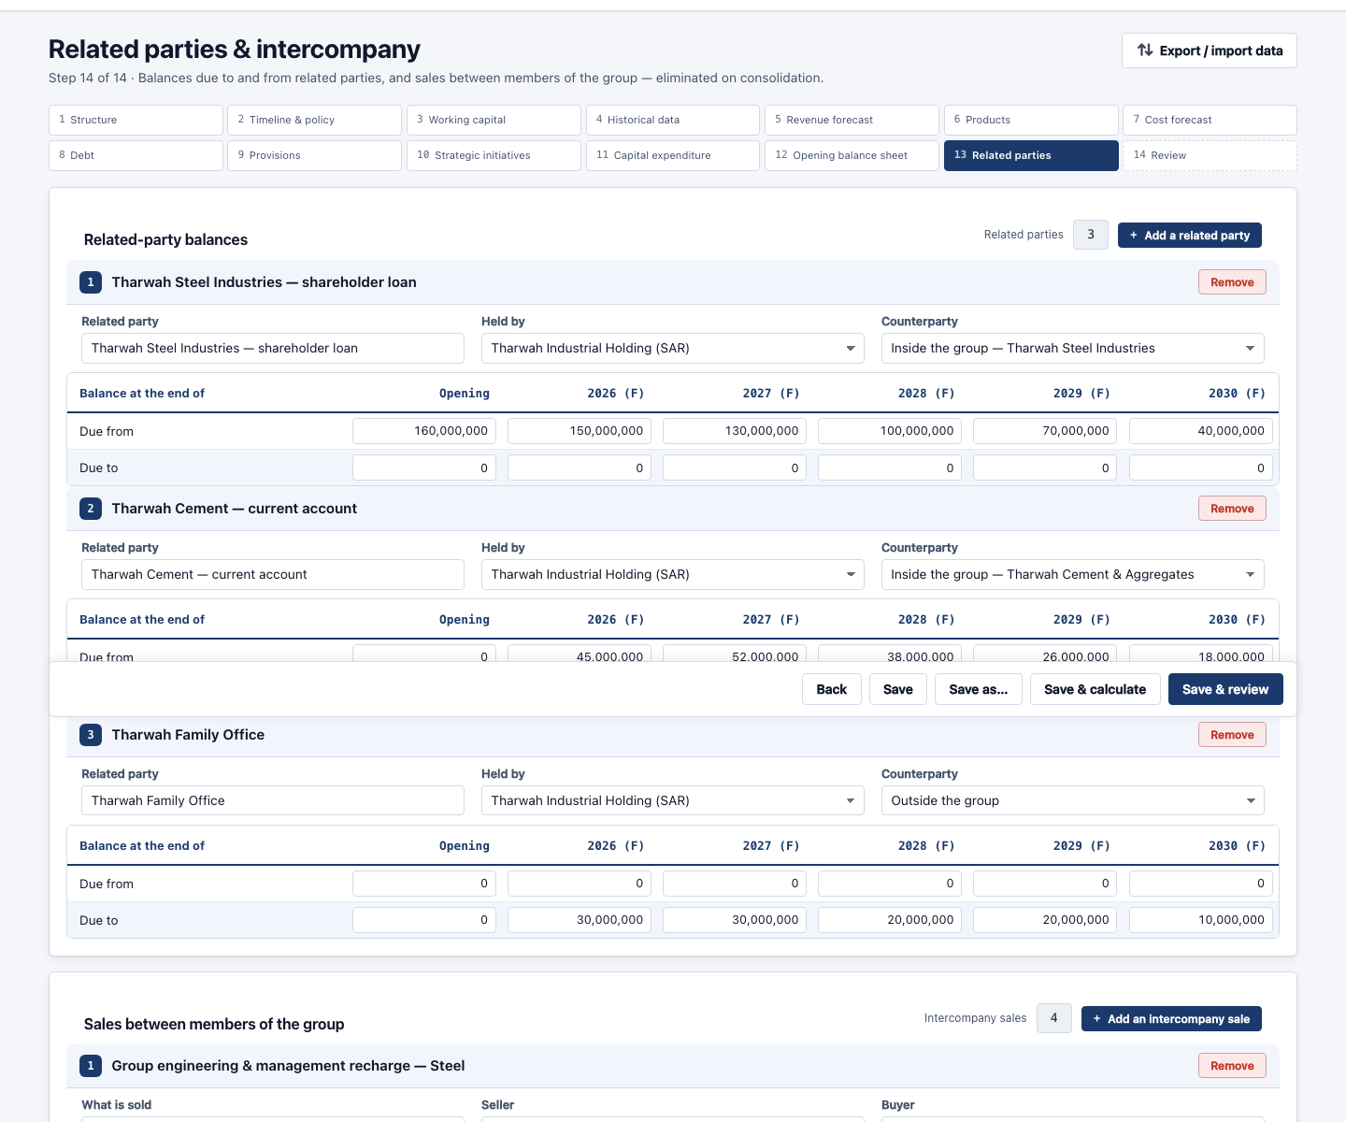
Step 13 — Related parties, on the Tharwah plan.

Step 14 — Review & completeness
The last screen. It lists everything still blank or still zero, and takes you straight to it.
You must fill in
- Nothing — this is the check, not an entry screen
What you can choose
- Filter — show everything, or only what really matters
Worth knowing: Work through this list and the plan is complete.
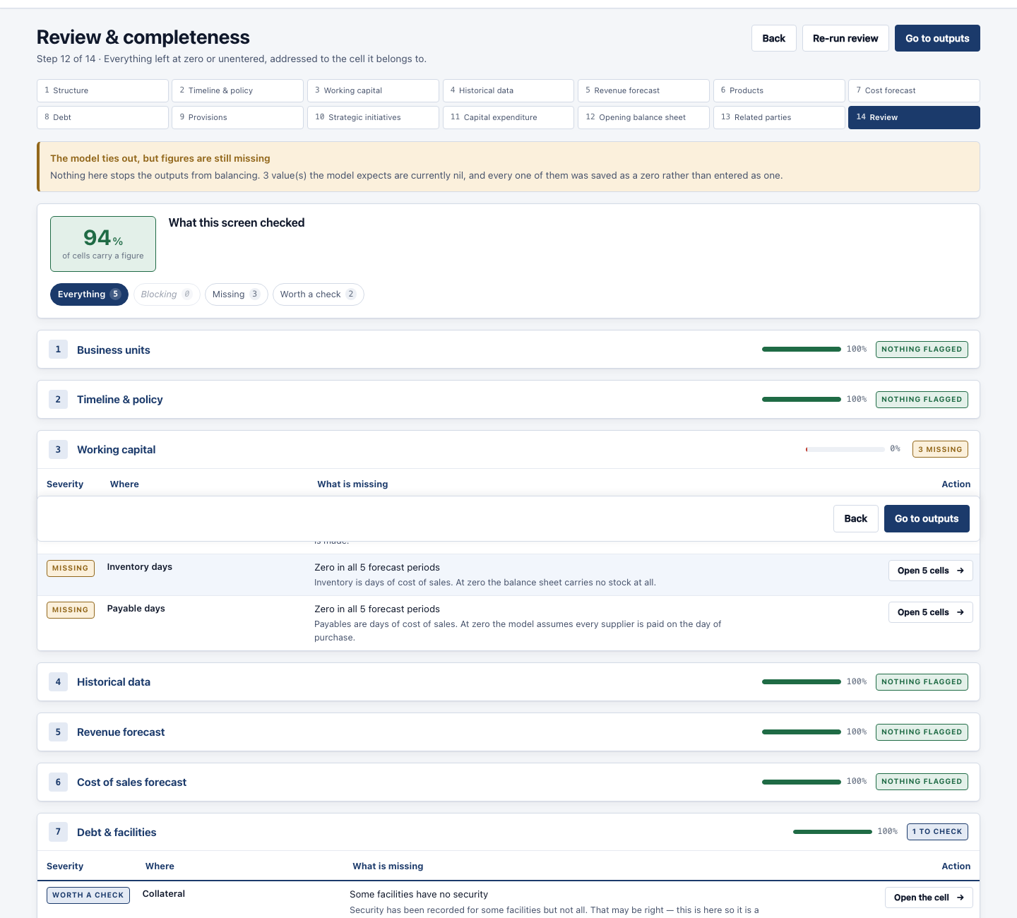
Step 14 — Review & completeness, on the Tharwah plan.

What you get back
Fourteen output screens. Every one of them has the same three controls at the top: which case to read (best, base, worst), which part of the business to read, and which currency to show it in.
Screen | What it tells you
Dashboard | The headline numbers and six charts — revenue, profit, cash, margins, working capital.
Actual analysis | The closed years on their own: what happened, and against what you had planned.
Revenue mix | Where the revenue comes from, and how the mix shifts over the plan.
Initiatives | What each new project adds, and what it costs.
Income statement | Revenue down to profit, year by year.
Cash flow | Money in and out, by operating, investing and financing.
Liquidity | The same cash flow as sources and uses, and the lowest point the plan reaches.
Balance sheet | What is owned and owed at each year end.
Ratios | Margins, returns, debt cover and the working capital cycle.
Debt & facilities | Every loan, what is owed, what is repaid and what it costs.
Provisions | Each provision, what is charged and what is settled.
Sensitivity | Six assumptions flexed either side of the plan, and where the plan breaks.
Consolidation | How the companies add up to the group, and what was removed.
Products | Each product from its revenue down to what it is really worth after overheads.

Dashboard
The whole plan on one screen. The faded bars on the left are the closed years; the dashed line is where the forecast begins.
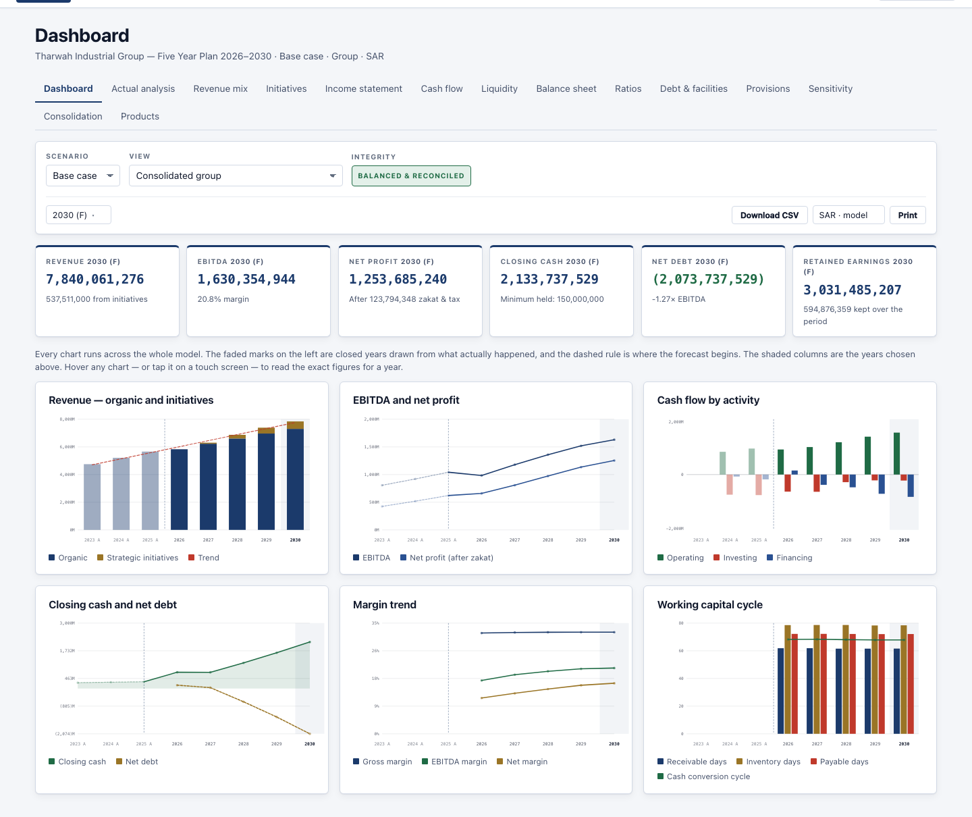
Dashboard — Tharwah, base case, whole group.

Income statement
Revenue down to profit. Closed years and forecast years side by side, so the plan can be read against what actually happened.
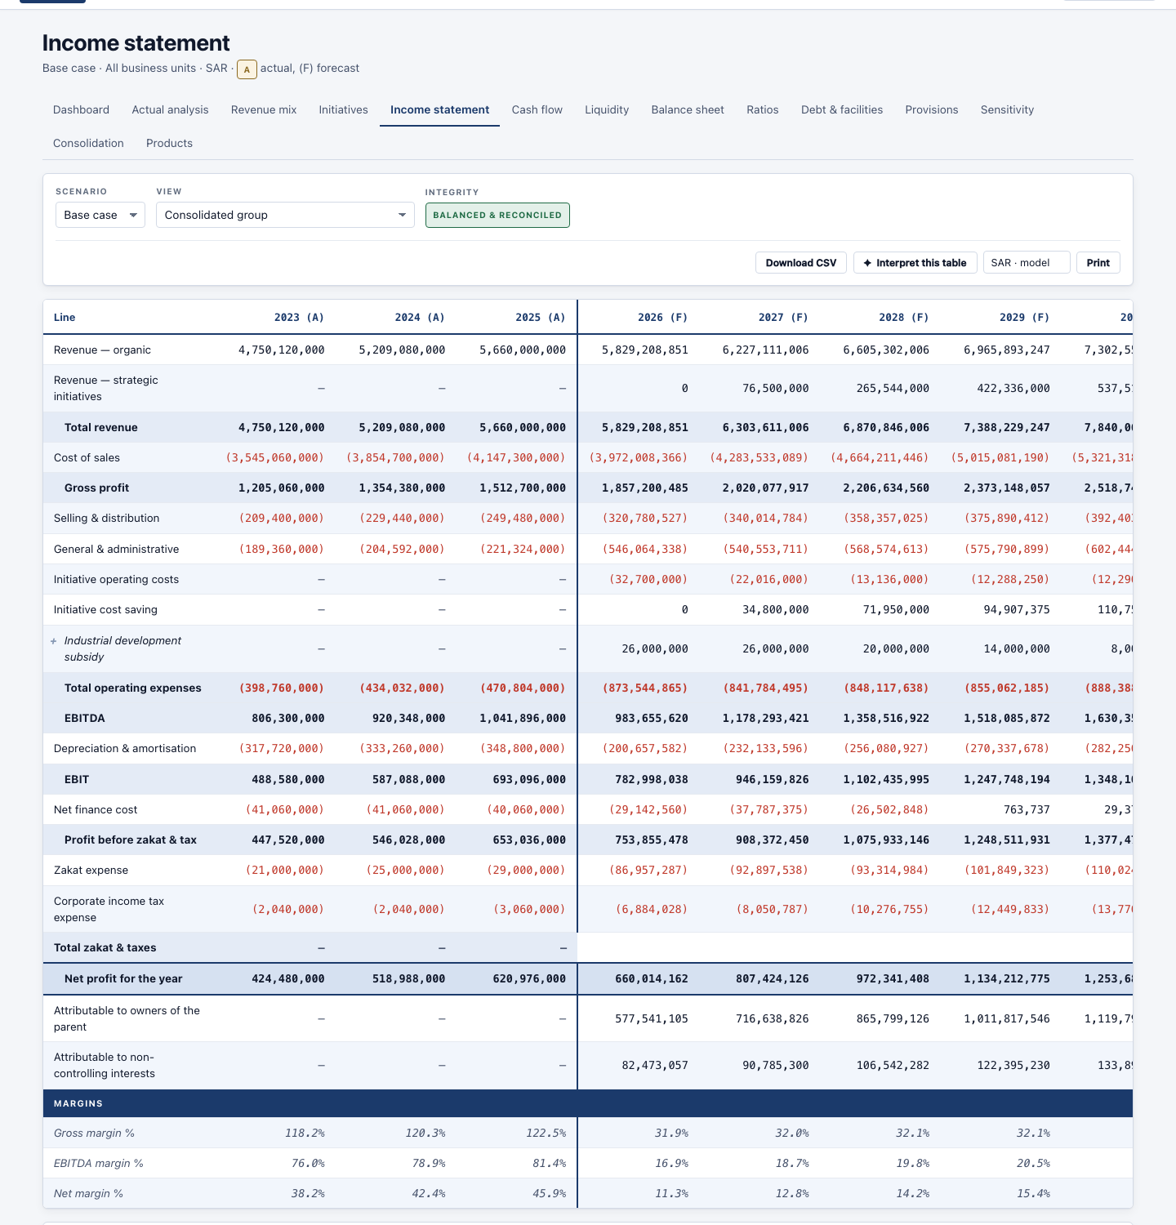
Income statement — Tharwah, base case, whole group.

Cash flow
Operating, investing and financing — and the three of them reach the movement in the bank exactly.
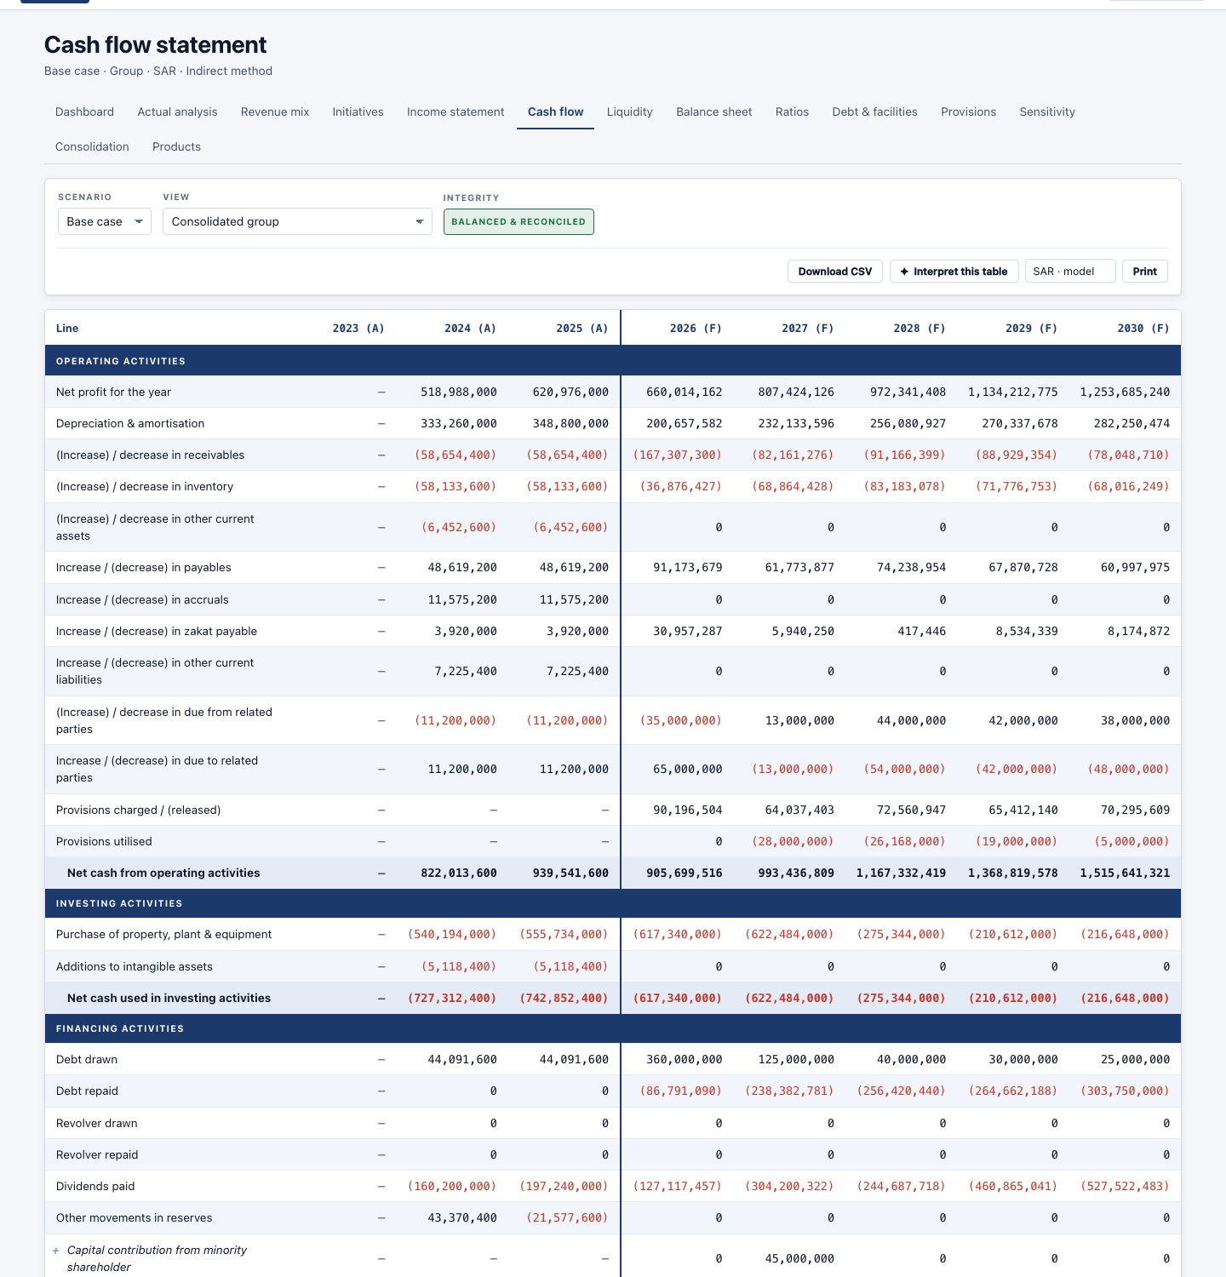
Cash flow — Tharwah, base case, whole group.

Balance sheet
What is owned and owed at each year end. The system checks it balances and says so at the top of every screen.
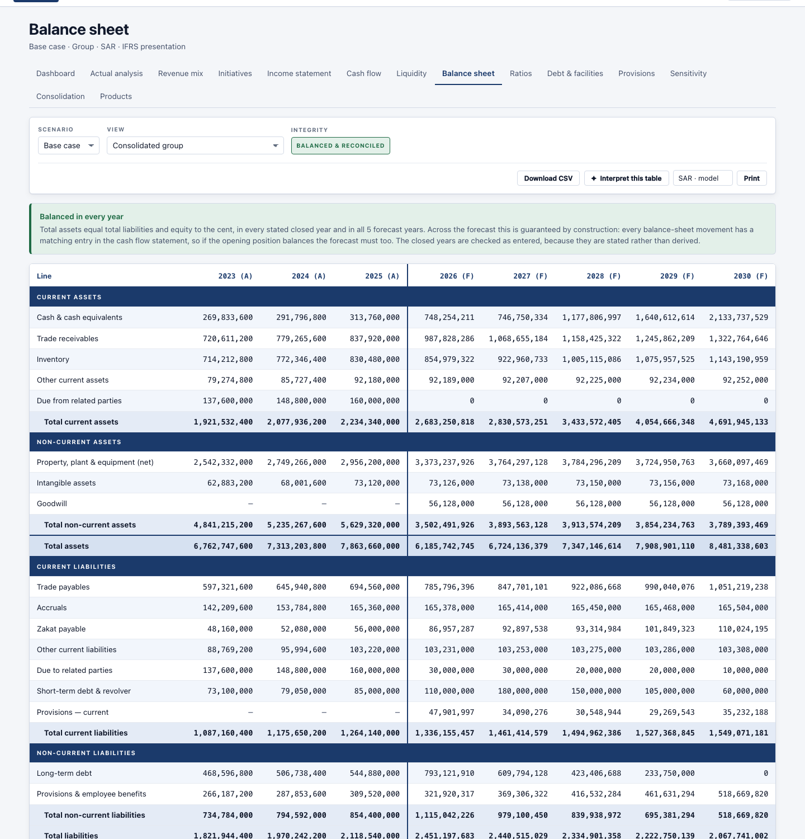
Balance sheet — Tharwah, base case, whole group.

Liquidity
The same cash flow shown as sources and uses, with the lowest point the plan reaches — that is the funding it needs.
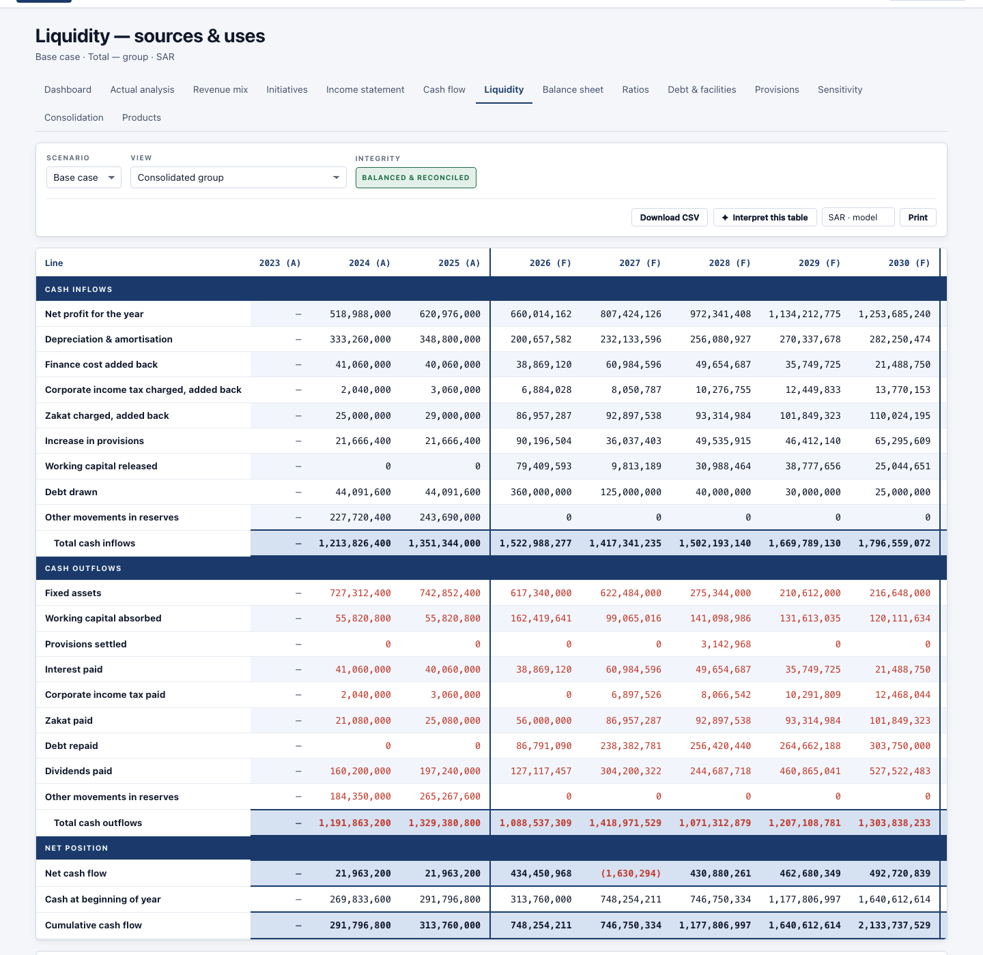
Liquidity — Tharwah, base case, whole group.

Ratios
Margins, returns, cover and the cash cycle, all derived from the statements rather than typed.
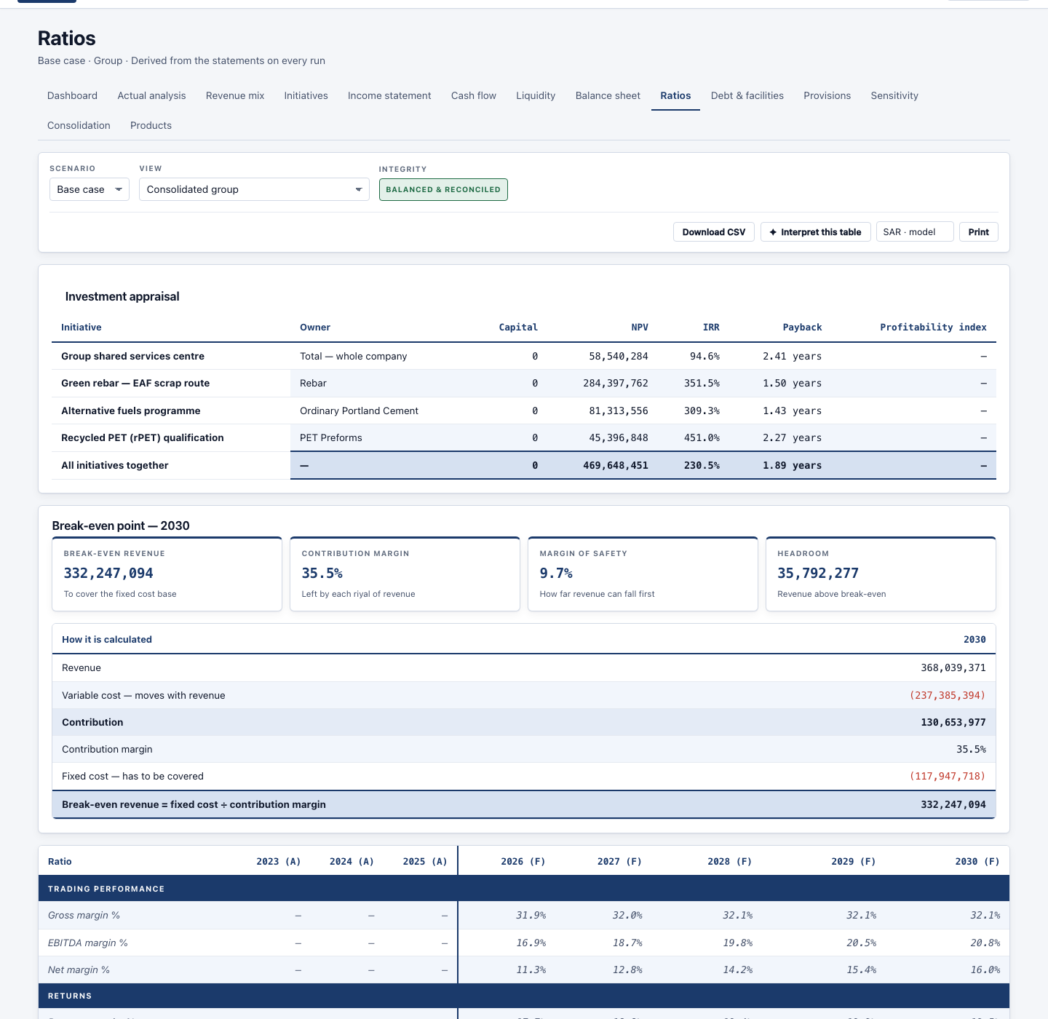
Ratios — Tharwah, base case, whole group.

Products
Each product from revenue down to what it is really worth once it has carried its share of the overheads above it.
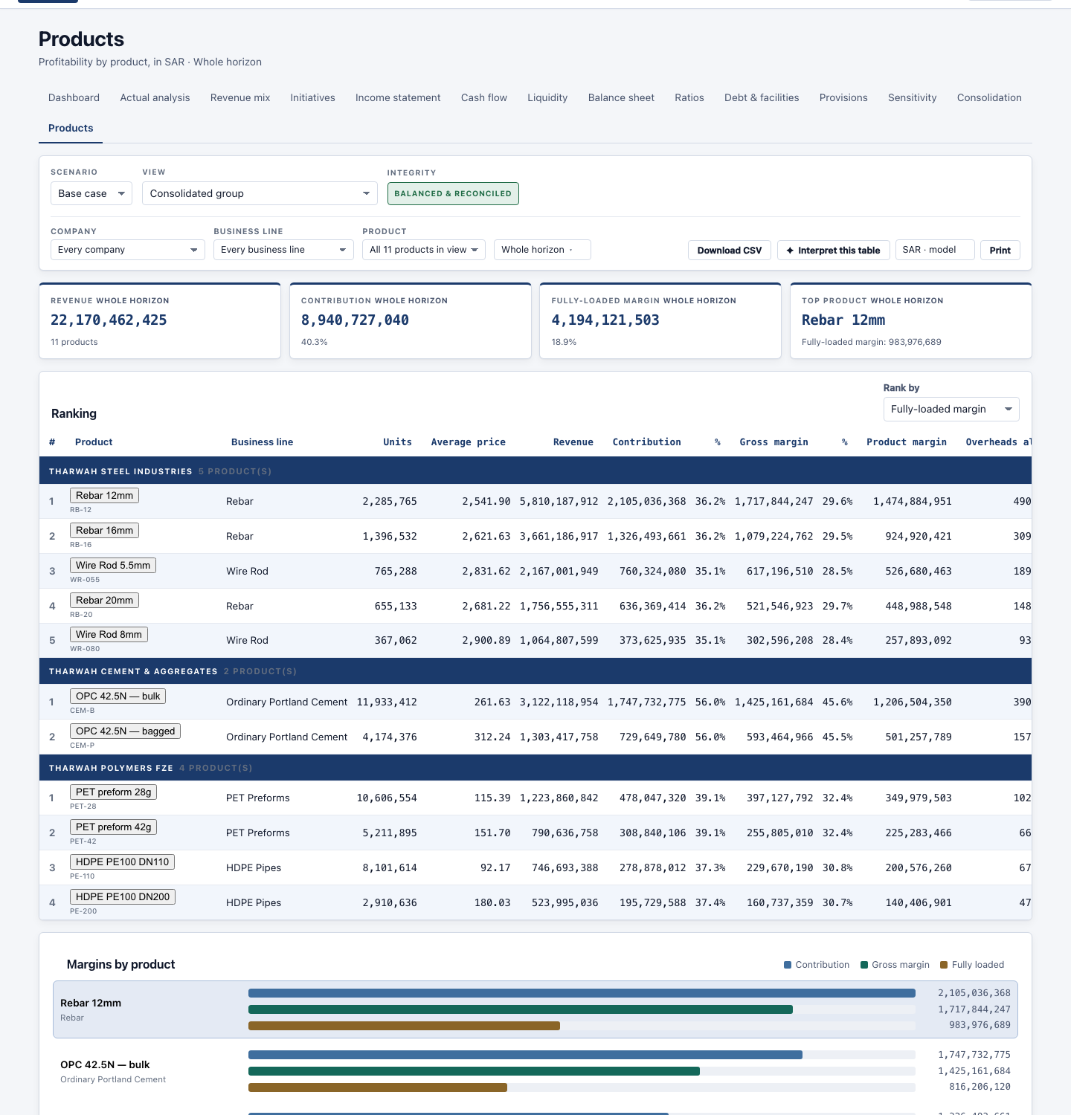
Products — Tharwah, base case, whole group.

Sensitivity
Six assumptions flexed either side of the plan, each on its own, and the point at which the plan stops working.
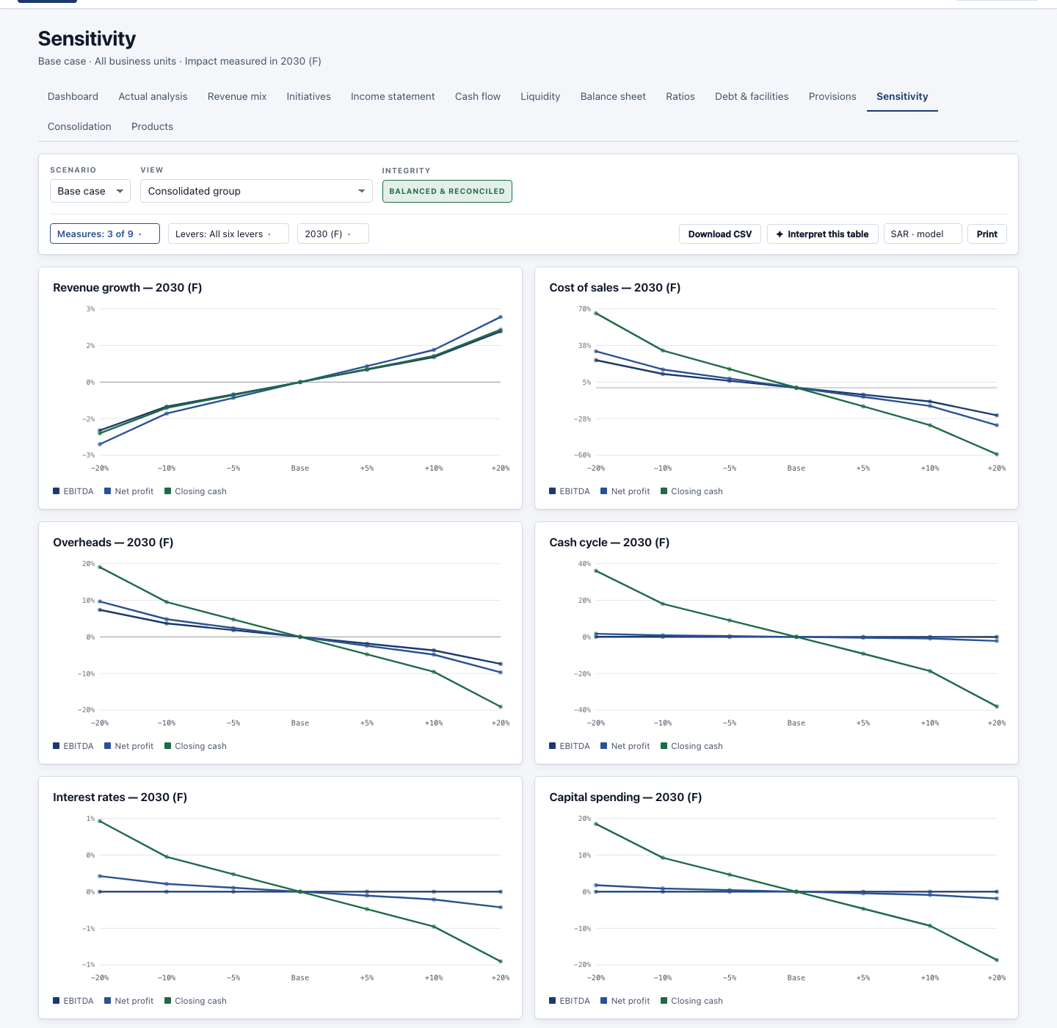
Sensitivity — Tharwah, base case, whole group.

Consolidation
How the companies add up to the group: what each contributes, and what was removed because the group cannot sell to itself.
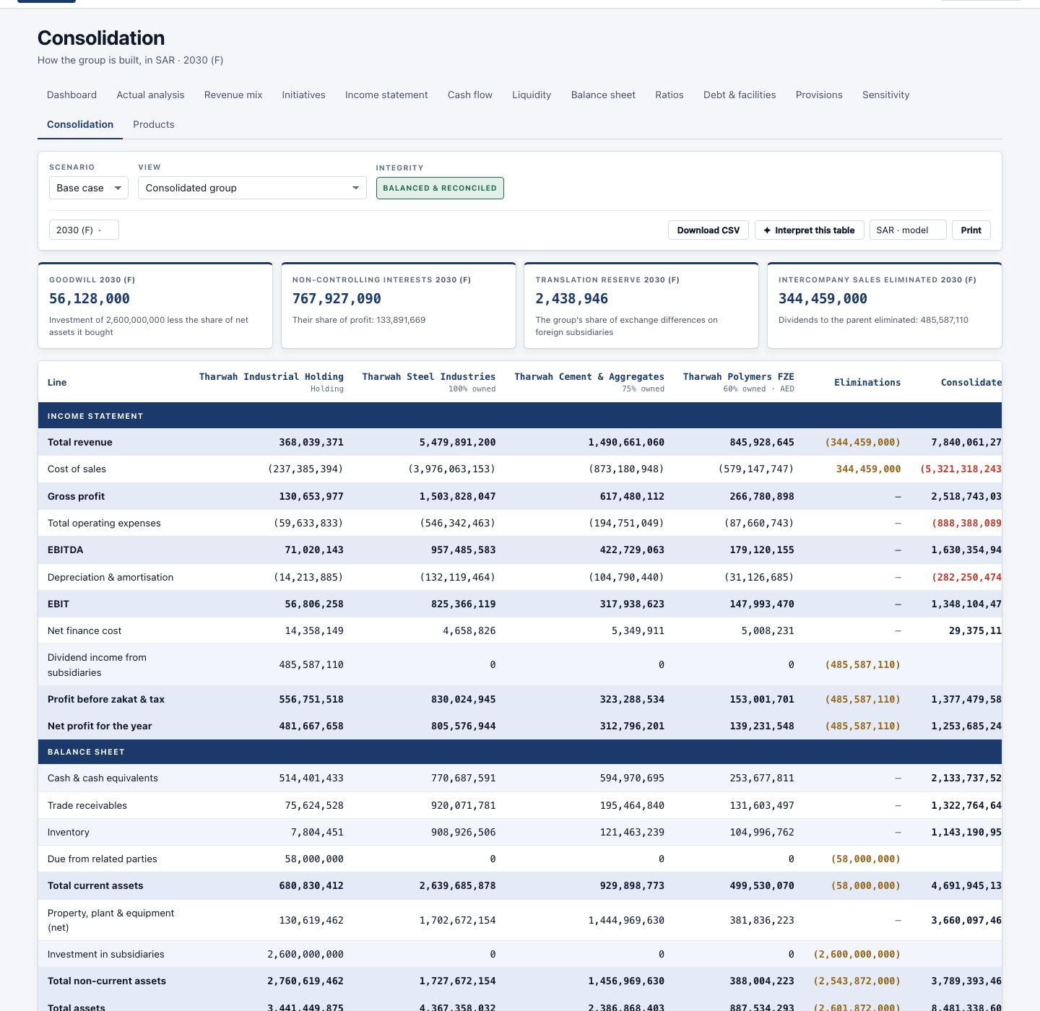
Consolidation — Tharwah, base case, whole group.

The other four screens
Beside the inputs and the outputs, the bar across the top carries four more.
Report
The printed pack: the statements, the charts and your own written notes under each section, ready to print or hand over. You choose which sections go in it.
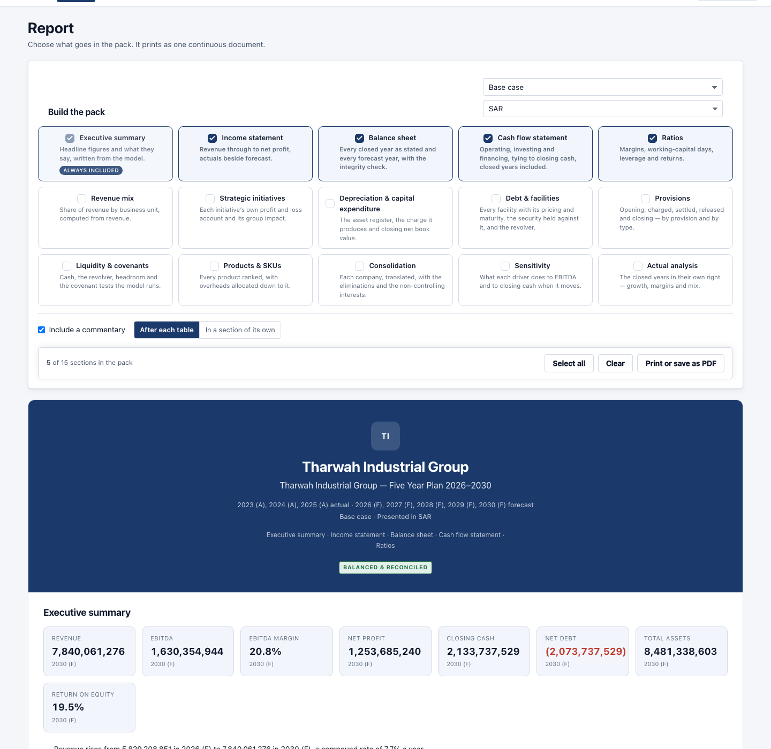
Report — the pack, with the sections you choose.
Budgeting
A budget is built department by department, pulled from the plan as a starting point. Each department fills in its own; the head approves it; the group adds them up and compares them against the plan.
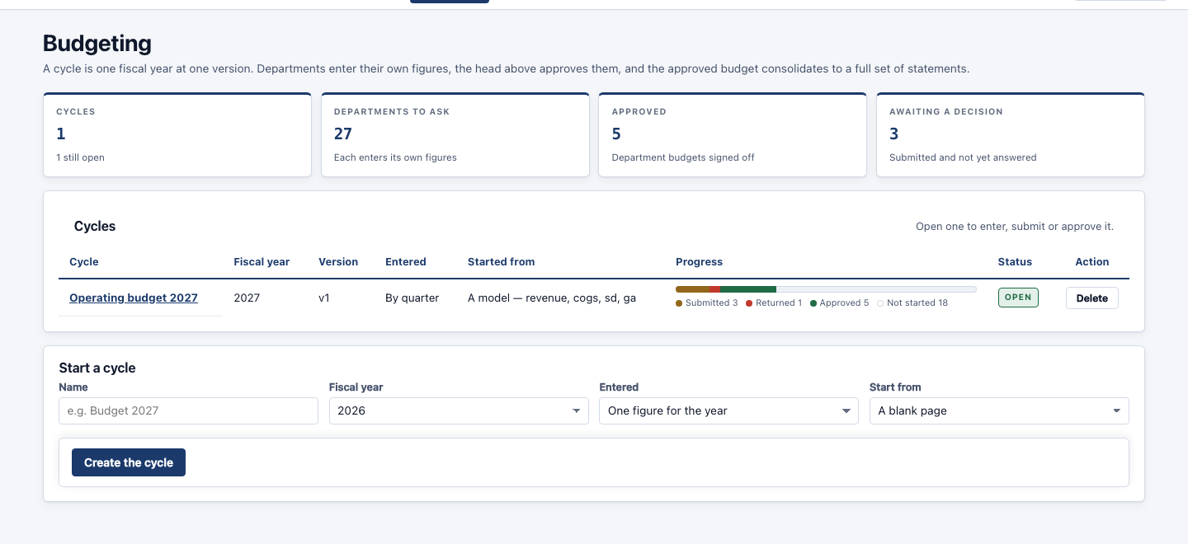
Budgeting — a cycle per year, built on the org chart.

Org structure
Who reports to whom, and which part of the business each person owns. This is not decoration: it is what decides which lines a person fills in and which numbers they read. A department can sit on a company or on a division, and that single choice is what makes somebody a division head rather than a company one.
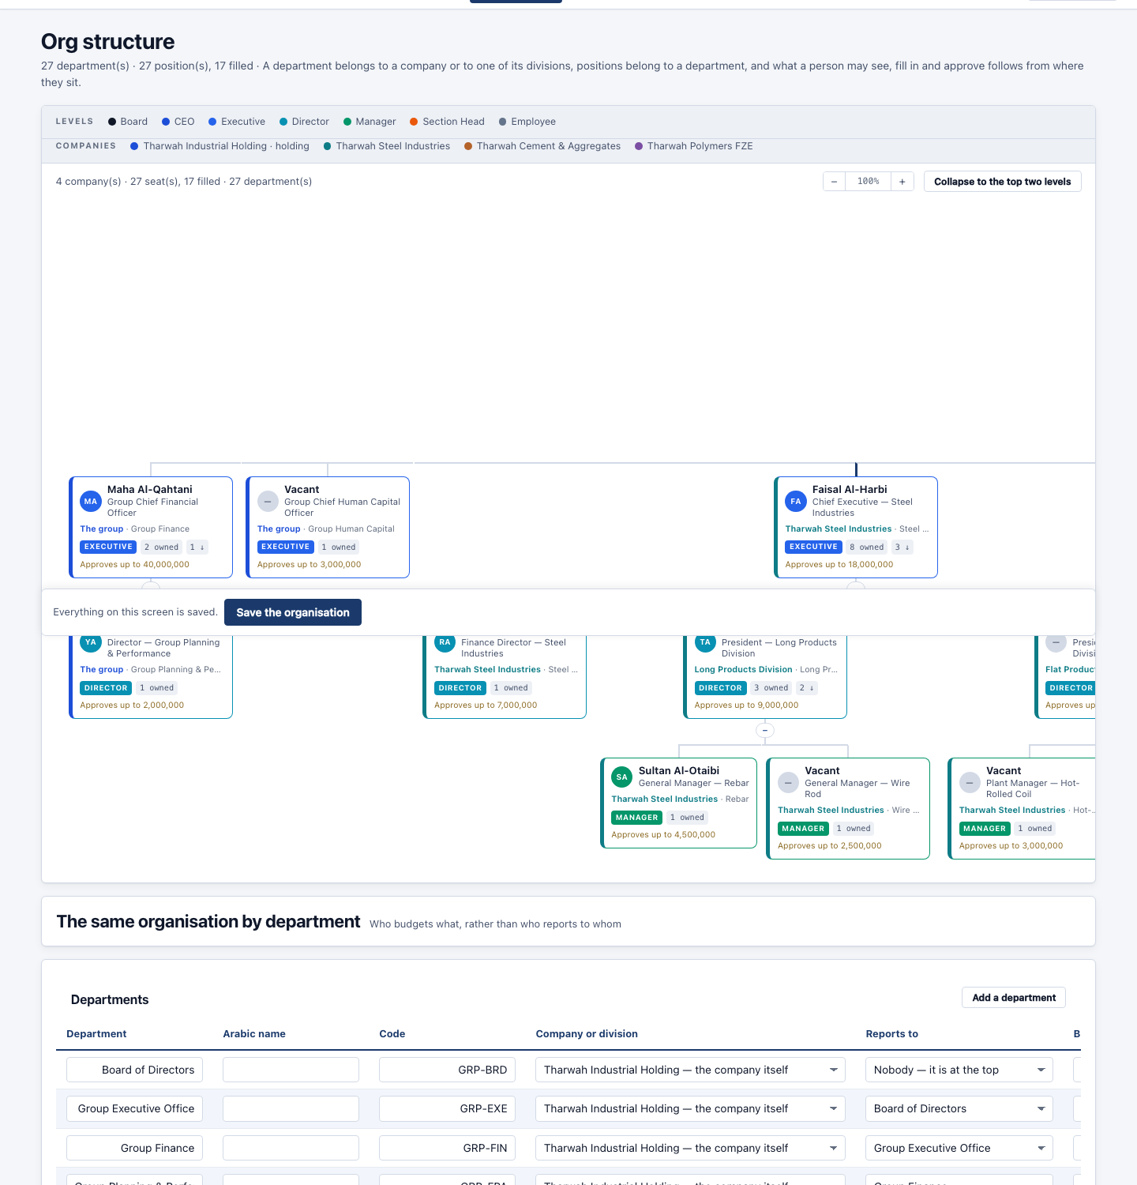
Org structure — the chart, and the seats that decide what each person sees.
Model comparison
Two plans side by side, line by line, so you can see exactly what changed between a first draft and a final one — or between last year’s plan and this one.
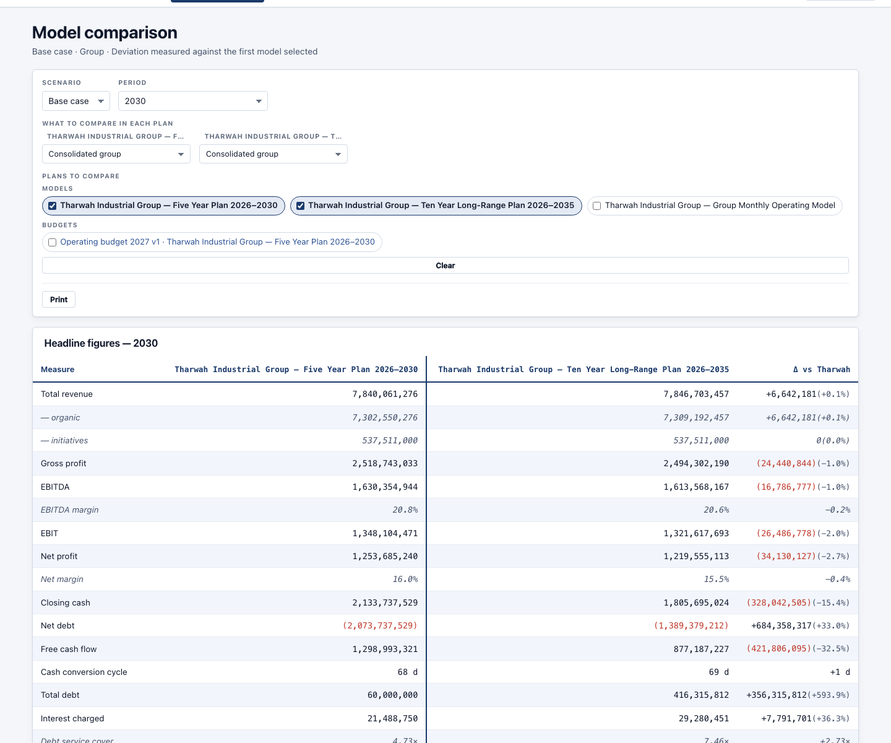
Model comparison — two plans, line by line.

How the numbers are worked out
In plain words, so you know what the system is doing with what you type.
From your entries to the profit and loss
- Revenue — last year’s revenue for the line, grown by the rate you set. Strategic initiatives are added on top, separately, so the growth figure stays like-for-like.
- Cost of sales — the variable percentage you set, applied to that revenue, plus the fixed amount — and the fixed amount rises each year with inflation.
- Selling and admin costs — the same way. This is where the overheads you allocate to products come from.
- Depreciation — worked out asset by asset from what you bought and how long it lasts.
- Interest — worked out facility by facility from what is drawn and the rate — plus interest on the overdraft if the plan needs one, and interest earned on spare cash.
- Tax or zakat — at the rate and method you set.
From the profit and loss to the cash and the balance sheet
- Working capital — your collection, inventory and payment days turn revenue and cost into receivables, inventory and payables. The change in those balances is what moves cash.
- The cash flow — profit, add back what did not move cash, adjust for working capital, take off what was bought, add what was borrowed, take off what was repaid and paid out.
- The balance sheet — every balance rolls forward — opening, plus what was added, less what was taken away. It has to balance, and the system checks every year.
- The overdraft — if cash would fall below the minimum you set, the overdraft is drawn to hold it there. If there is spare cash, it is repaid.
How a group is added up
- Each company is calculated on its own — in its own currency, with its own balance sheet.
- Foreign companies are translated — balances at the closing rate, the profit and loss at the average rate, and the difference goes to a translation reserve — the standard treatment.
- Sales inside the group are removed — so the group does not count a sale from one of its own companies to another.
- The share you do not own is separated — shown as non-controlling interests.
How a product is costed
This is the chain on the Products screen, top to bottom:
Line | What it is
Revenue | Units × price, or the amount you typed.
less Direct variable cost | Materials, labour and other costs that follow each unit.
= Contribution | What each sale contributes before anything fixed.
less Direct fixed cost | Costs the product carries whether it sells or not.
= Gross margin
less Indirect costs | Its share of the running costs of its business line.
= Product margin
less Allocated overheads | Its share of the line’s, the division’s, the company’s and the group’s overheads — by the driver you chose, or the percentage you stated.
= Fully-loaded margin | What the product is really worth.

Any share that reaches a business line with no products under it is reported as unallocated rather than quietly dropped.

How the system checks itself
Every output screen carries a badge at the top. “Balanced & reconciled” means all of the following were true when the numbers were worked out:
- The balance sheet balances, every year.
- The cash flow reaches the cash on the balance sheet, every year.
- Retained earnings roll forward correctly.
- Every subtotal is the sum of the rows printed under it.
- Reading by quarter or by month adds up to reading by year.
- The business lines add up to the group.
- The ratios agree with the statements they come from.
If any of these failed, the badge would say so and name the year.
What was checked before this report was written
Check | Result
Automated tests | 394 passed, 0 failed
Database and structure | Every table and column present
Engine integrity checks | 1,011 checks, no disagreements
Formula checks | 315 formulas, no disagreements
Statement checks | 15 models × 3 cases, ten families of check, all agree
Schedules, products and ratios | 23 models, 69 runs, no disagreements
Accounting review | 423 checks, no disagreements
Unchanged-result check | 195 runs against the previous engine, no differences
Screen and permission checks | 228 + 270 requests, no failures
Languages | English, Arabic, French, Spanish, German — all complete

Quick reference
The order to work in
# | Step | Must you fill it?
1 | Structure | Yes
2 | Timeline & policy | Yes
3 | Working capital | Yes
4 | Historical data | Yes
5 | Revenue forecast | Yes
6 | Products & SKUs | Only if you use products
7 | Cost forecast | Yes
8 | Debt & facilities | Only if you have debt
9 | Provisions | Only if you have them
10 | Strategic initiatives | Optional
11 | Capital expenditure | Only if you buy assets
12 | Opening balance sheet | Yes — and it must balance
13 | Related parties | Only if you have them
14 | Review & completeness | Read it before you finish

If something looks wrong
- The badge does not say “Balanced & reconciled” — go to step 12 and check the opening balance sheet balances.
- A line shows nothing — go to step 14, Review — it lists every blank and takes you to it.
- A screen is missing from your bar — your role or your authorities do not include it. Your administrator can change that.
- You can open a screen but not save it — it has been granted to you to read only. The screen says so at the top.
- The group total is not what you expect — check the Consolidation screen — sales inside the group are removed, and a part-owned company is split.
A note on saving
Nothing is calculated until you save. Every input screen has “Save” and “Save & continue”; “Save as…” puts your changes into a new copy of the plan and leaves the original as it was.

